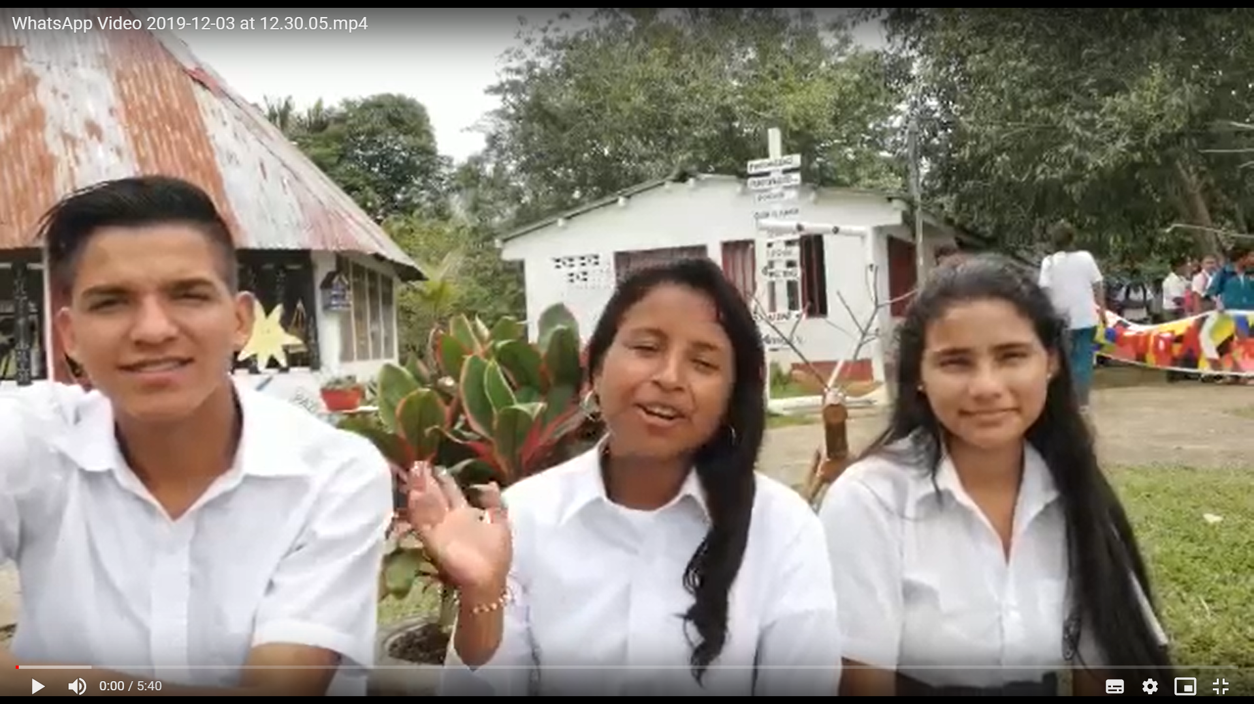
https://drive.google.com/open?id=13Kssp92s-JitoXdxQl9C2XEKuo0qbuwO

